ArsTropica WordPress Theme Documentation

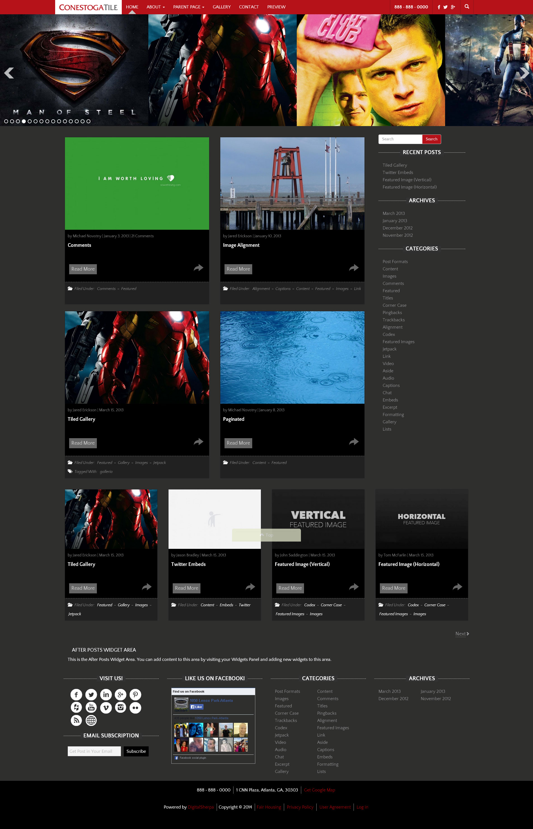

Table of Contents

Introduction to the ArsTropica Responsive Framework for WordPress 7

A Quick Introduction 8

Framework Features 8

What is a Framework? 8

What is a Child Theme? 8

Child Theme Files 8

How to Install the ArsTropica Responsive Framework (and a Child Theme) 10

Installing ArsTropica Responsive Framework from Inside WordPress 11

Installing Using FTP 13

Activating a Theme 14

An Overview of the Basic Settings of the ArsTropica Responsive Framework 16

Company Information 18

Phone Number 19

Company Address 19

Social Media 20

Enable In-built Theme Social Widget 20

Color and Hover 21

URL fields 21

Twitter URL 21

Website URL. 21

Theme SEO 22

Minfy Assets (for faster loading) 22

Google+ Publisher URL 22

Google+ Author URL (Global Override) 23

Validate Google Authorship 23

Facebook Page URL (Open Graph SEO) 23

Mobile Contact Form 24

Enable Mobile Contact Form 24

Display on Page. 24

Theme Settings 25

Enable Front End Theme Customizer for Guests 25

Presets 26

Choose Header Slider 27

Number of Words in Excerpt 27

Number of Words in Excerpt on Homepage 27

Number of Posts on Homepage 27

Number of Posts per Page 27

Show Widget Placeholders 28

Enable Sticky Navigation 28

Display Related Posts (required YARPP plugin) 28

Appearance Sections 29

Link Color 29

Fonts 29

Background Color 29

Border 30

Icons 30

Buttons 30

Custom CSS 32

Theme Images 33

Default Thumbnail Image 34

Company Logo 34

Site Favicon 34

Import / Export 35

Reset Theme Options 36

Individual Theme Settings 37

Default Theme Settings Values 38

Using a Static Home Page 39

Custom Page Templates 40

Creating a Menu 41

Plugins 43

Plugin Inventory 44

Required Plugins 44

Optional Plugins 44

Theme Plugins 44

Plugin Settings 45

Soliloquy Slider 46

Regenerate Thumbnails 55

Yet Another Related Posts Plugin 56

ArsTropica Guest Theme Preview Plugin 57

ArsTropica Featured Posts 59

Company Logo & Link 59

Mobile Contact Form 59

Related Posts 59

Theme Social Icons 59

Widgets 60

ArsTropica Featured Posts 61

Company Logo & Link 63

Mobile Contact Form 64

Theme Social Icons 66

Facebook Like Box 67

Shortcodes 68

Available Shortcodes 69

Filters Reference 70

Framework Filters 71

at_google_authorship_rel 71

at_responsive_comments_popup_link 71

at_responsive_content_grid 71

at_responsive_content_grid_classes 71

at_responsive_dropdown_menu_classes 71

at_responsive_excerpt 71

at_responsive_nav_menu_args 72

at_responsive_pagination_links 72

at_responsive_post_entry 72

at_responsive_theme_mod_{$setting_id} 72

Child Theme Filters 73

at_responsive_child_menu_end_lvl 73

at_responsive_child_menu_start_lvl 73

at_responsive_child_theme_mod_{$setting_id} 73

Hooks Reference 74

Framework Hooks 75

at_responsive_after_entry 75

at_responsive_hero 75

at_responsive_loop_end 75

at_responsive_loop_start 75

at_responsive_mobile_contact 75

Child Theme Hooks 76

at_responsive_primary_sidebar 76

at_responsive_secondary_sidebar 76

at_responsive_slim_deck 76

at_responsive_tall_deck 76

Error Messages 77

Common Error Messages 78

# Introduction to the ArsTropica Responsive Framework for WordPress

## A Quick Introduction

The ArsTropica Responsive Framework is a proprietary, highly extensible, search-engine optimized WordPress Theme Framework featuring multiple widget areas, integration with ArsTropica's client infrastructure, grid-based responsive layouts and much more.

### Framework Features

* Perfect for turnkey deployment, but also easily extensible for child theme development
* Search Engine Optimized - including integration with Facebook Open Graph and Google Rich Snippets
* Widget-ready areas (including mobile-only) with different configurations possible in Child Themes.
* Easy to Implement Customization Options
* Multiple layout options for 2 and 3 column designs
* Asset compression to increase load times
* Automatic integration with the ArsTropica CRM and the ArsTropica Dashboard
* Guest Demo functionality - allowing easy showcasing of Theme functionality and features via a single link.

### What is a Framework?

A theme framework is a robust WordPress theme that acts as a platform on which your WordPress website can be created. The ArsTropica Responsive Framework integrates all of the SEO, security, and customization features to help you deploy the best site possible in minutes.

You can build your site using one of the available Child Themes and customize the appearance of the entire blog without having to write one line of code! You may also create additional Child Themes by leveraging the framework's library and many features.

### What is a Child Theme?

A child theme is a layer of code that sits on top of the ArsTropica Responsive Framework, comprised mainly of the design elements of your site, but can also extend and modify the functionality of the ArsTropica Responsive Framework's default functions.

The Framework / Child Theme structure of site building is great, mainly because it separates out the performance issues of your site from the design issues. So, if you use a child theme, you can design all day long, without ever touching the critical, underlying code that makes ArsTropica Responsive sites so powerful.

Design what you want, and don't worry about bringing your site down in the process.

### Child Theme Files

A ArsTropica Responsive child theme will generally be comprised, in part, of the following elements

* Screenshot --An image of the design that the theme will create around your content.
* Style sheet (required) --Determines the look of the site based on the HTML generated by ArsTropica Responsive and WordPress.
* css/default.css File (required) -- Contains the main styles for the child theme.
* Functions file (required) --Connects the child theme to the framework. Can also be used to add, remove, and modify elements from the framework defaults.
* index.php File (optional) --Generally used to generate the site structure and position widgets and create the site layout.
* home.php File (optional) -- Used to generate an alternate homepage for non-static blogs.
* page-{slug/id} (optional) -- Used to generate a specialized page template for a specific page.
* templates/content.php File (optional) -- Organizes the layout of the page/post/archive/etc. content. When used with index.php, it controls the appearance of each page on the blog.
* Other template files.

These elements are grouped together in what’s known as a child theme directory and can be activated like any other WordPress theme.

# How to Install the ArsTropica Responsive Framework (and a Child Theme)

Installing the ArsTropica Responsive Framework and a child theme is the same process for installing any WordPress theme, except that you're essentially installing two themes.

There are two ways to install the ArsTropica Responsive parent theme or a ArsTropica Responsive child theme:

* Manually with an FTP client (File Transfer Protocol transfers files from one host to another).
* Automatically through the upload feature in the WordPress dashboard.

**PLEASE NOTE**: The ArsTropica Responsive Framework must be installed prior to activating a child theme and must remain in the /wp-content/themes/ directory on your server. The directory that contains the ArsTropica Responsive framework files must be named "arstropica".

## Installing ArsTropica Responsive Framework from Inside WordPress

1. To install a theme from inside your WordPress admin panel, mouse over the Appearance menu item and select "Themes."

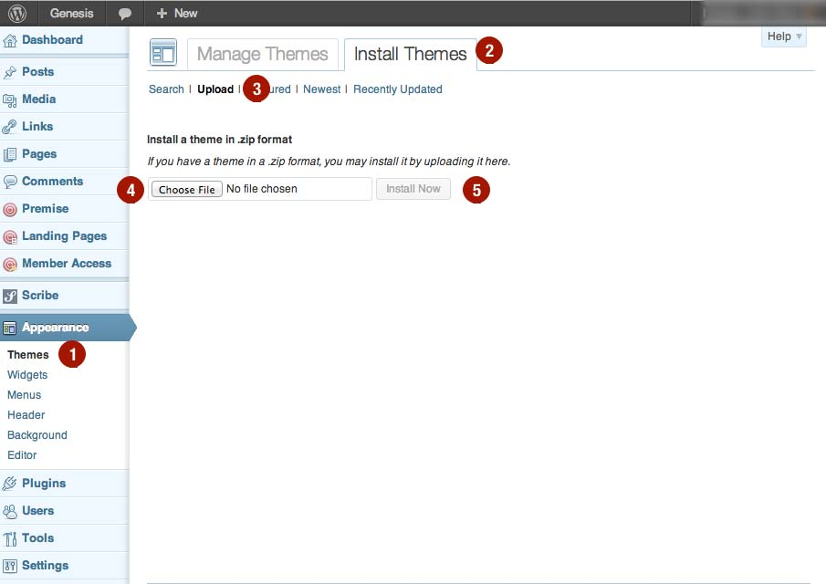

1. At the top of the screen, click on "Install Themes."
2. Click on the “Upload" link.
3. Using the "Choose File" button, find the zip file for the theme.
4. Once you have the zip file in the Choose File field, the "Install Now" button will become active. Click the "Install Now" button.
5. You will see the "Theme installed successfully" message, indicating a successful upload.
6. "Live Preview" will display your site using the newly installed theme in a preview mode so you can see what it would look like.

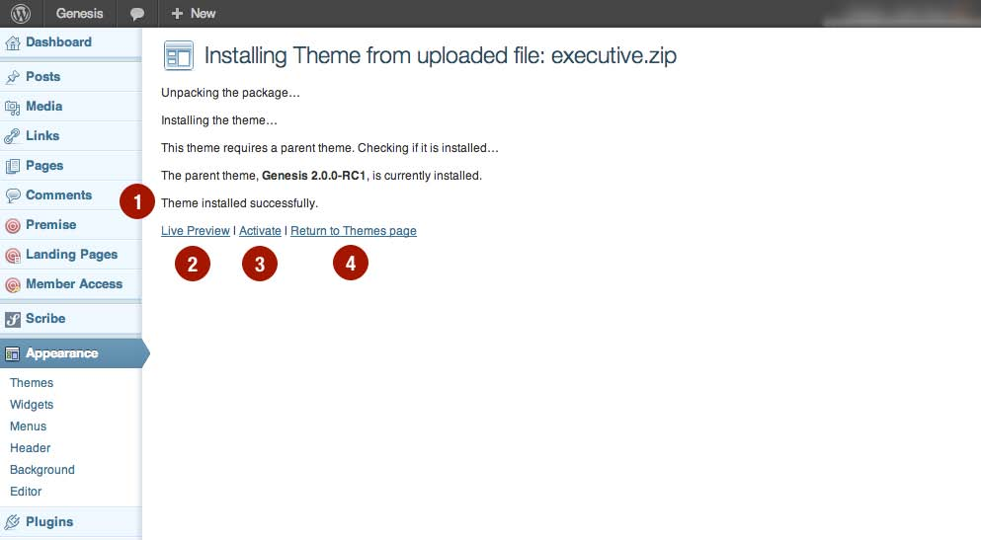

1. "Activate" will apply the newly installed theme to your live site.
2. "Return to Themes page" will take you to the Appearance > Themes page. Here you can see all the installed themes.

**To install a ArsTropica Responsive Child Theme, return to the "Install Themes" screen and repeat steps 1-5 above.**

## Installing Using FTP

If you choose to install ArsTropica Responsive framework and your child theme via FTP (or your web host’s control panel) first unzip the theme package to your computer's desktop.

Some popular FTP programs to use for this process include CuteFTP, FileZilla, and FireFTP for Firefox.

The three-step install:

1. Connect to your site via FTP and navigate to the themes directory (typically /wp-content/themes/).
2. Upload the entire "arstropica" directory to the themes directory. The folder name must be "arstropica". Also, there must not be any other directories before ArsTropica Responsive/style.css and the rest of the files.
3. Upload the entire child theme directory to /wp-content/themes/. If you are renaming the child theme directory, avoid using special characters, including spaces.

## Activating a Theme

1. After you have installed the ArsTropica Responsive Framework (and a ArsTropica Responsive Child Theme), activate it by hovering your mouse over "Appearance" and select "Themes."

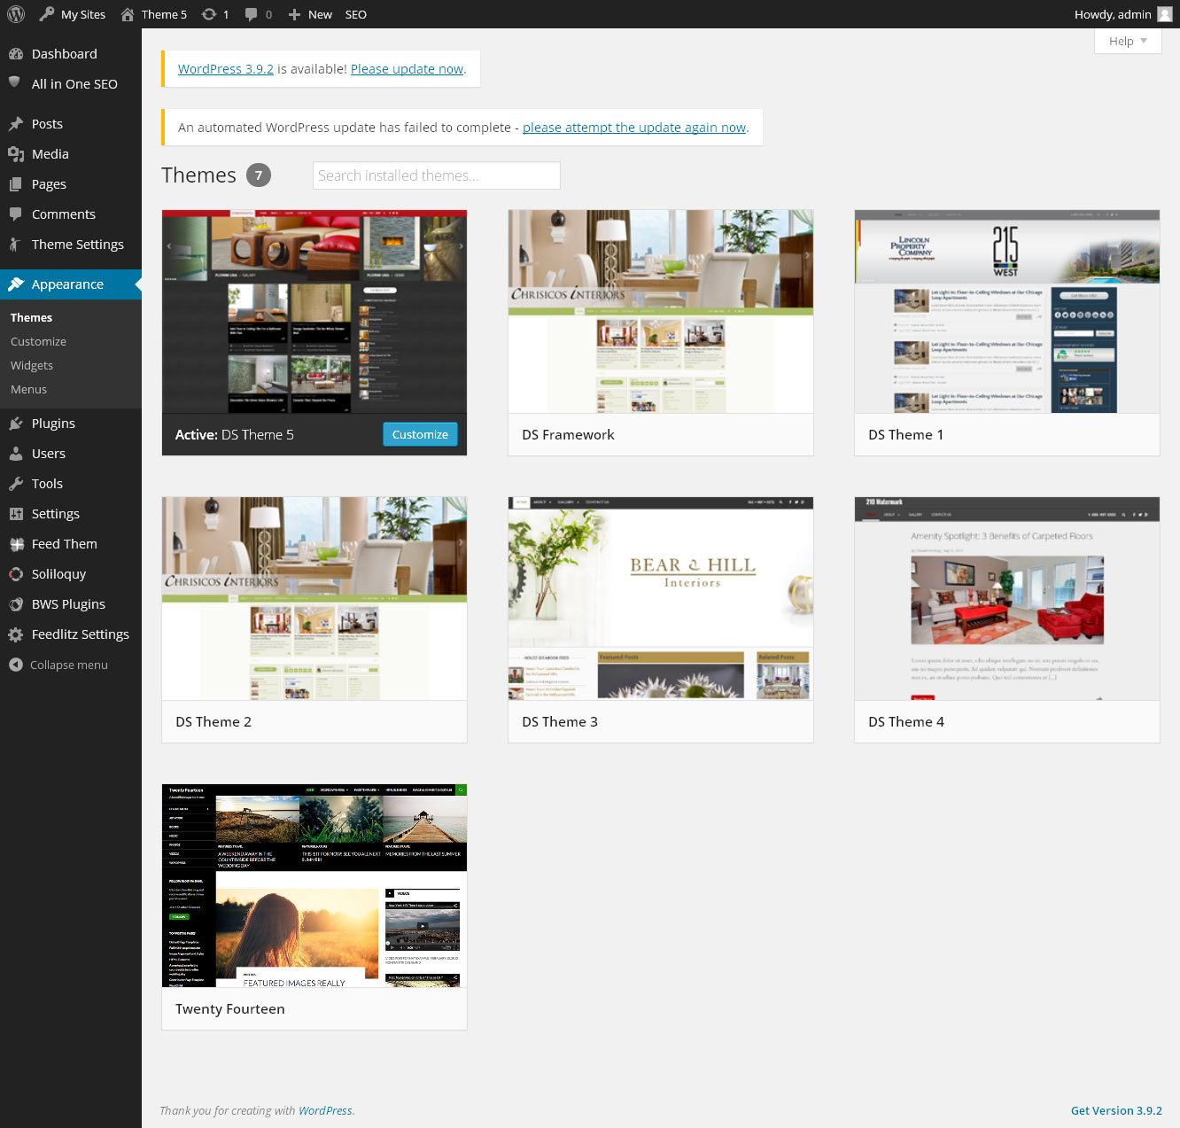

1. You will see a screenshot of all the available themes, including the ArsTropica Responsive Framework and ArsTropica Responsive Child Themes you have installed. Click the "Activate" link below the theme you want to install.

**PLEASE NOTE: If you are using a ArsTropica Responsive Child Theme, it is not necessary to activate the ArsTropica Responsive Framework theme. Be sure the ArsTropica Responsive Framework is installed and activate a Child Theme.**

Your ArsTropica Responsive Theme is activated as confirmed by the "New theme activated" message. And the ArsTropica Responsive Theme displays in the "Current Theme" area.

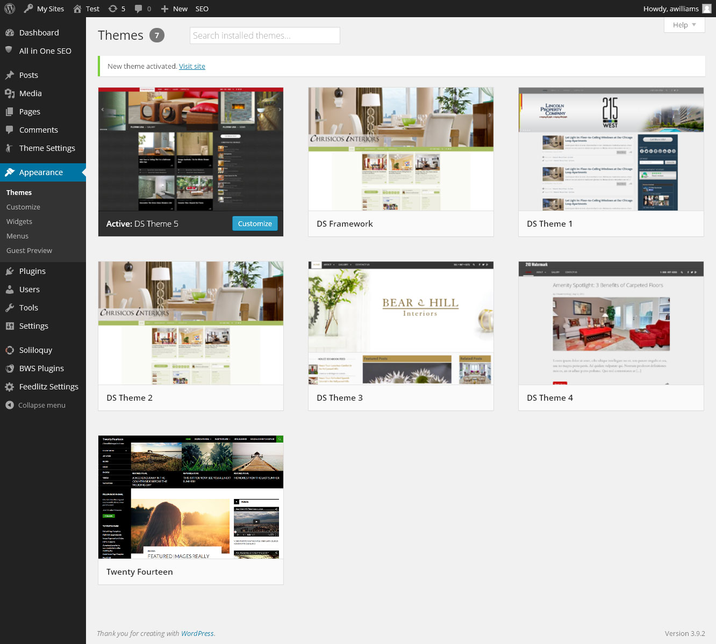

# An Overview of the Basic Settings of the ArsTropica Responsive Framework

Theme Settings

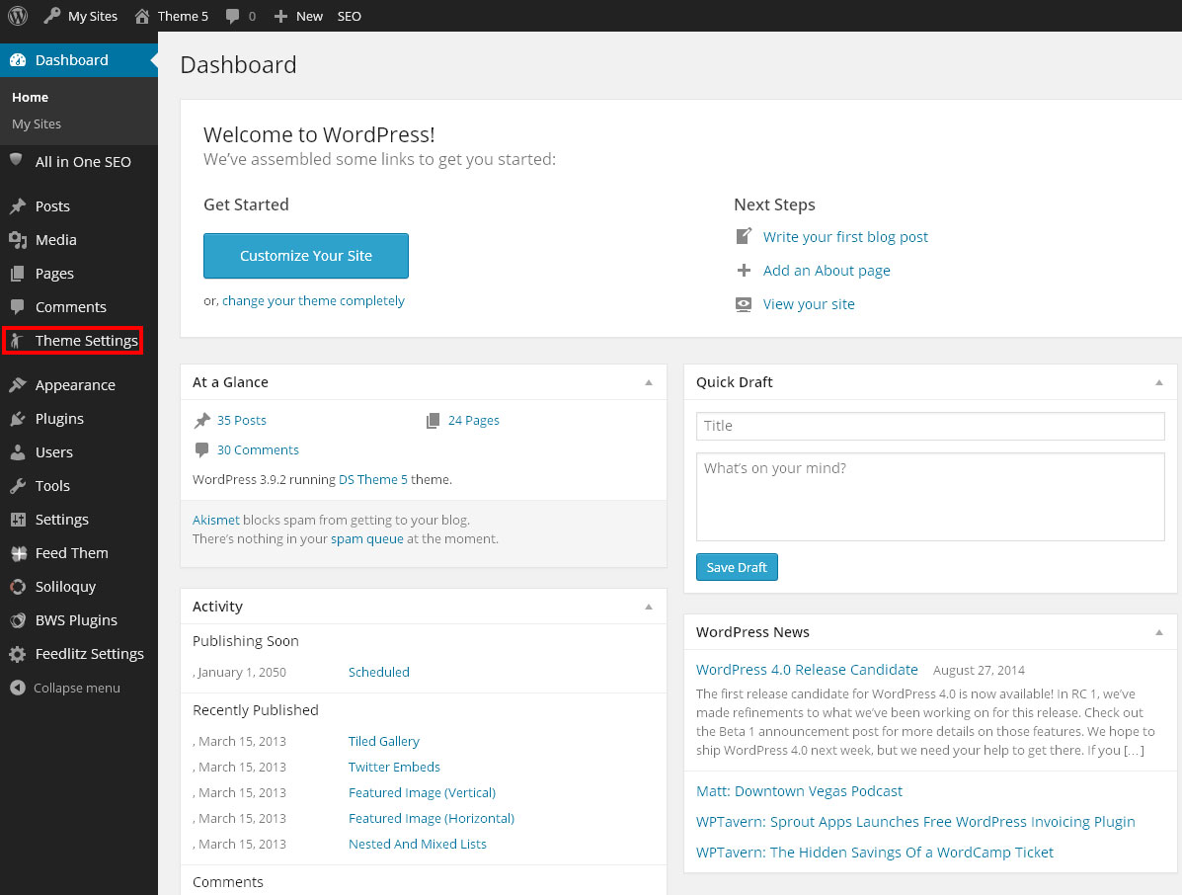

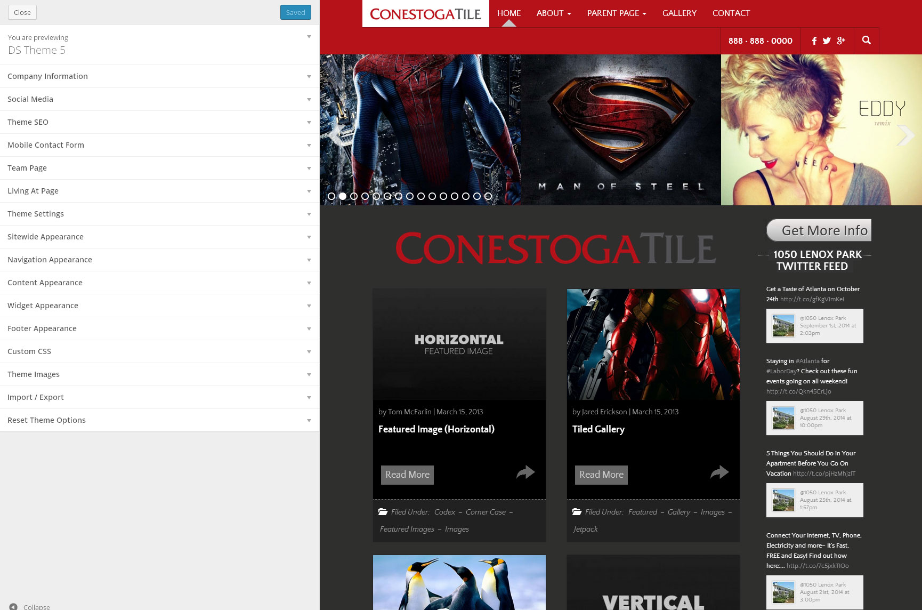

1. Once your child theme is activated, you'll see a new menu item on the WordPress Dashboard with several sub-menu options. Child themes and ArsTropica Responsive-specific plugins may add additional content and/or settings to default WordPress settings pages.
2. The Theme Settings page contains general options to control the way your theme will behave.
3. Each of the boxes can be collapsed or expanded by clicking the drop-down arrow.

**Let's look at each of the Theme Settings.**

## Company Information

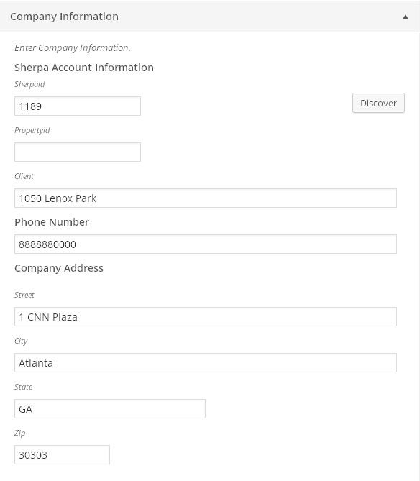

The Company Information section lets you enter information about the blog owner that will be displayed throughout the blog and used to configure certain features.

### Phone Number



Enter a 10 digit phone number to display in the header, footer and modal forms.

### Company Address



Enter a contact address for the blog owner. (Used to generate the Google Maps link in the footer.)

## Social Media

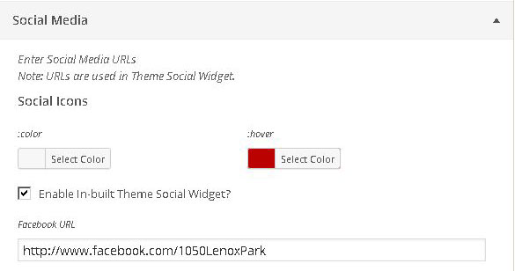

The Social Media section handles activation of the Theme Social Media widget as well as content sharing on certain social media networks.

### Enable In-built Theme Social Widget



Checking the "Enable In-built Theme Social Widget" box will activate the Theme Social Media widget on the Widgets page, allowing the widget to be placed in one of the theme's widget areas.

### Color and Hover

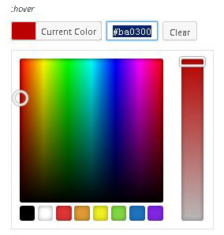

Selecting either a color or hover (color) changes the color of the icons displayed by the Theme Social Media widget.

### URL fields

Entering a URL in one or more of these fields activates a corresponding icon in the Theme Social Media widget that links to the site specified by the URL.

### Twitter URL

In addition to providing a link to a Twitter profile, the Twitter user id associated with the URL is also used to share content from the blog on the Twitter social network.

### Website URL.

In addition to providing a link to a website, the Website URL is also used as the link for the Company Logo and Link widget. Omitting the URL will force the widget to use the blog URL.

## Theme SEO

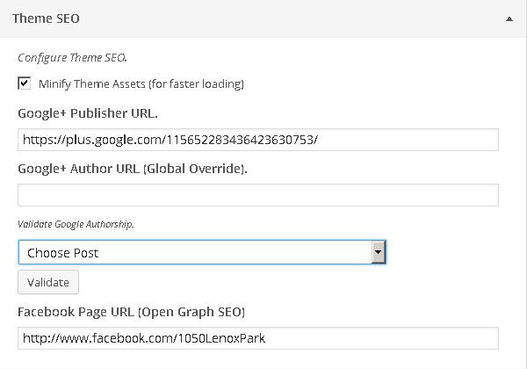

The Theme SEO section handles Search Engine Optimizations features native to the ArsTropica Responsive framework.

### Minfy Assets (for faster loading)



Checking the "Minify Assets" box will increase the theme's load time by as much as 50% by combining and compressing JavaScript and CSS files that are loaded when the blog is displayed. It can be unchecked during debugging and theme development to make scripting easier.

### Google+ Publisher URL



Entering a Google+ Publisher URL activates the theme's content metadata functionality, providing Google with additional information about the content being displayed. This will aid the search engine in ranking the blog's content accurately and may also promote search engine results. The publisher URL must point to a **Google+** **page** not a profile.

### Google+ Author URL (Global Override)



If all posts on a blog are written on behalf of a single person, then the Google+ Author URL override may be used to attribute all blog posts to a single Google+ profile.

### Validate Google Authorship



After entering a publisher profile and either of a global Google+ profile, via override, or author profile, via the user profile, you can validate the framework's rich content functionality is working correctly by choosing a blog post from the drop-down menu and pressing the "Validate" button to open Google's Structured Data Testing Tool. If valid URLs have been used, you should see a page confirming that Google has successfully parsed the post content on the blog.

### Facebook Page URL (Open Graph SEO)



When content is liked or shared, Facebook (and sometimes, Twitter) use meta tags in the <head> part of the website to identify the content. Adding the account data for Facebook page / profile that owns the content will enable Facebook Insights for the content owner's domain, which Facebook uses to provide social analytics on statistics like how many times the site has been liked & shared on Facebook.

## Mobile Contact Form

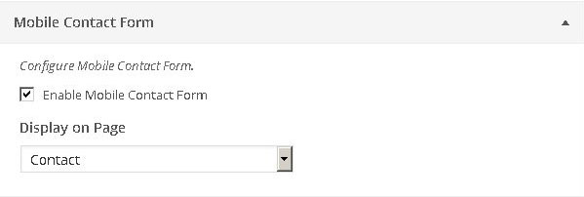

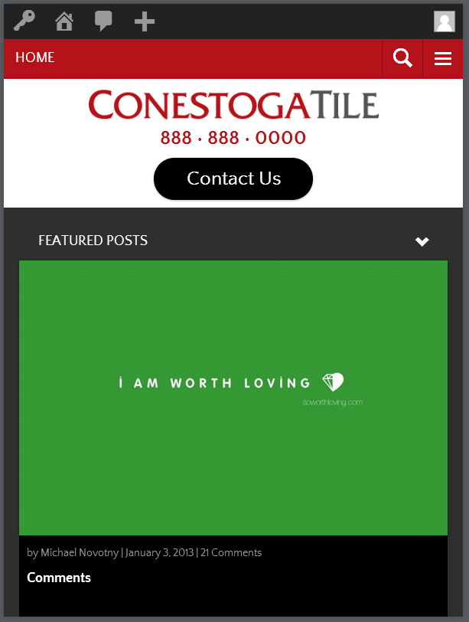

One of the features of the ArsTropica Responsive Framework is adapting functionality to different devices and resolutions. The Mobile Contact Form enables a widget that can be used to display a highly visible contact button that opens a responsive contact form on mobile platforms. This feature requires the Sherpa ID value to be entered in the Company Information section. If the Sherpa ID is missing, the contact button generated by the widget will link to the blog admin account email address.

### Enable Mobile Contact Form

Checking the "Enable Mobile Contact Form" box activates the Mobile Contact Form widget on the Widgets page.

### Display on Page.

If you would like the Mobile Contact Form to display from a menu item, select an existing page from the drop-down menu, and then **add that page to the WordPress menu**. Note that existing content on the selected page will not be displayed.

## Theme Settings

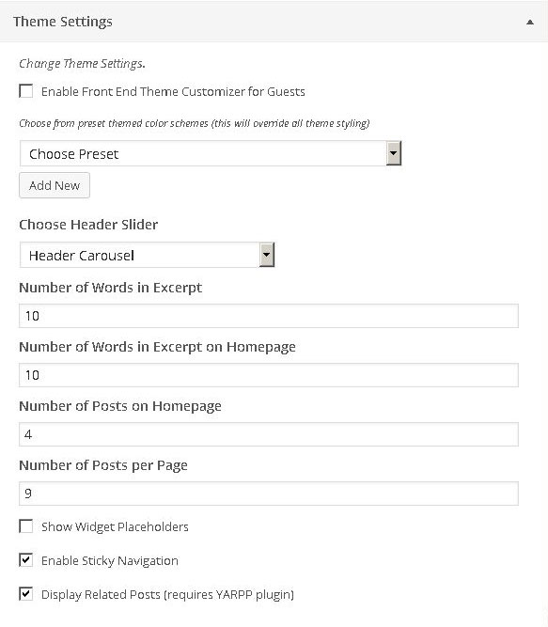

### Enable Front End Theme Customizer for Guests

Checking the " Enable Front End Theme Customizer for Guests" box activates the Guest Preview feature for the theme, allowing visitors to preview the theme's customization options on the front end by visiting the "/guestpreview" URL.

### Presets

This lets you save your theme's custom styling configuration as presets that can be loaded in the future.

1. Use the "Add New" button to open the Style Editor.

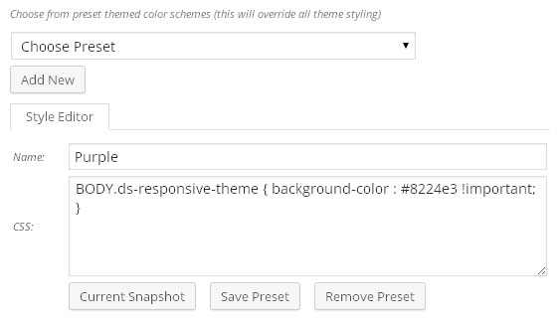

1. Take a snapshot of the current customization with the "Current Snapshot" button. The CSS for the customization will appear in the textbox.
2. Name and save the preset and it will appear in the drop-down menu for future use.

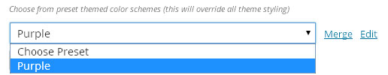

1. Select the preset to apply the saved customizations.
2. Use the "Merge" link to restore the preset customizations in the Theme Settings.
3. Use the "Edit" link to edit the preset.

### Choose Header Slider



Selects the slider created in Soliloquy for display in the header.

### Number of Words in Excerpt



Sets the number of words used to generate a post excerpt throughout the blog.

### Number of Words in Excerpt on Homepage



Sets the number of words used to generate post excerpts on the blog homepage.

### Number of Posts on Homepage



Sets the number of visible posts on the blog homepage.

### Number of Posts per Page



Sets the number of posts per page throughout the blog.

### Show Widget Placeholders



Checking the "Show Widget Placeholders" box displays placeholder text at all the empty widget area locations on the blog.

### Enable Sticky Navigation



Checking the "Enable Sticky Navigation" box fixes the theme's navigation menu at the top of the window.

### Display Related Posts (required YARPP plugin)



Checking the "Display Related Posts" box enables related posts, if any, to appear at the bottom of single post pages. The "Yet Another Related Posts Plugin" should be activated in order for this feature to work accurately.

## Appearance Sections

There are five sections that handle theme appearance.

1. Sitewide Appearance
2. Navigation Appearance
3. Content Appearance
4. Widget Appearance
5. Footer Appearance

Each section controls certain elements in different sections of the blog using one the following customization controls.

### Link Color

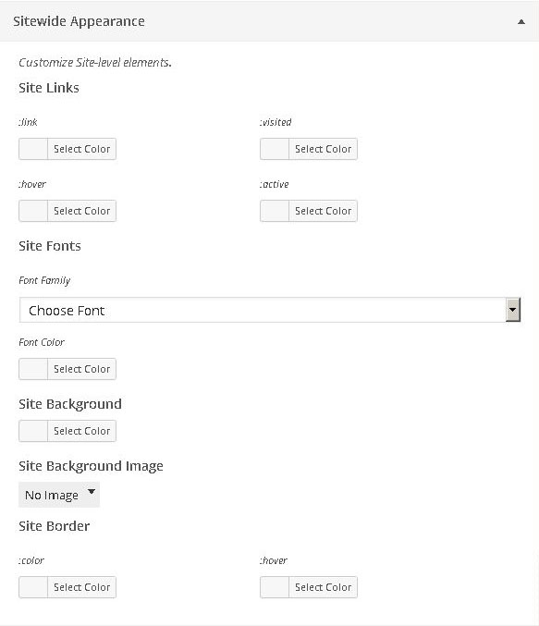

The Link Color Control allows you to choose a different color for the four possible states a link can assume (:link, :hover, :visited and :active).

### Fonts



The Fonts Control allows you to specify a font-family from a list of available fonts and a font color for text in a specified area or element.

### Background Color



The Background control allows you to specify a background color for a specified area or element.

Background Image

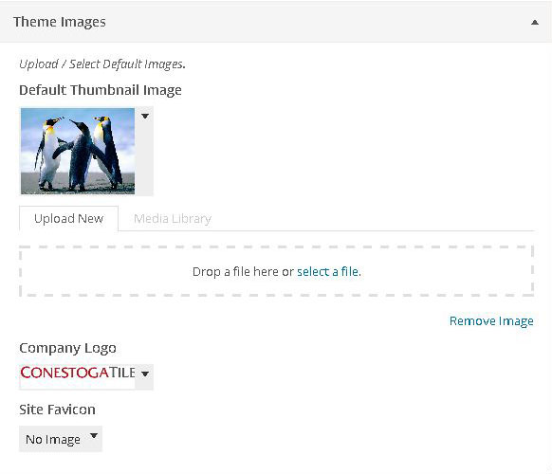

The Background Image control allows you to specify a repeating background image for a specified area or element.

### Border



The Border Control allows you to specify border colors for normal and hover states of a specified element or area.

### Icons



The Icons control allows you to specify colors for normal and hover states of icons.

### Buttons



The Buttons control allows you to specify colors for normal and hover states of buttons.

## Custom CSS

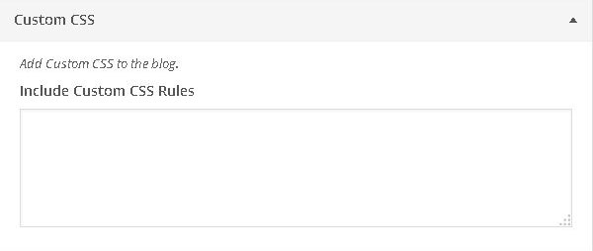

The Custom CSS Section allows you to add additional CSS stylesheet rules to the blog. These rules will be applied in addition to the customizations set in Theme Settings.

## Theme Images



You can specify an image to be used in this section by either uploading the image from your hard drive or selecting an image from the media library.

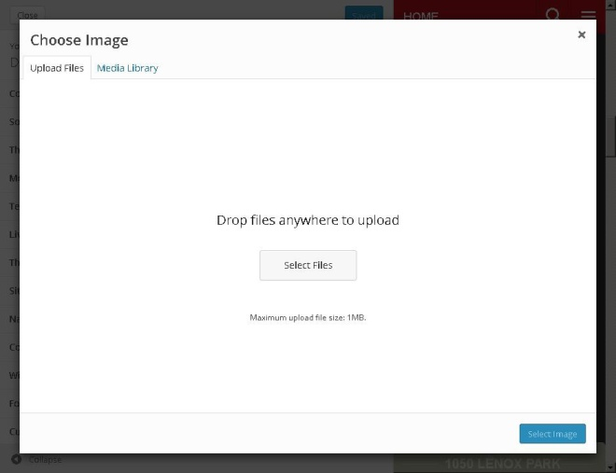 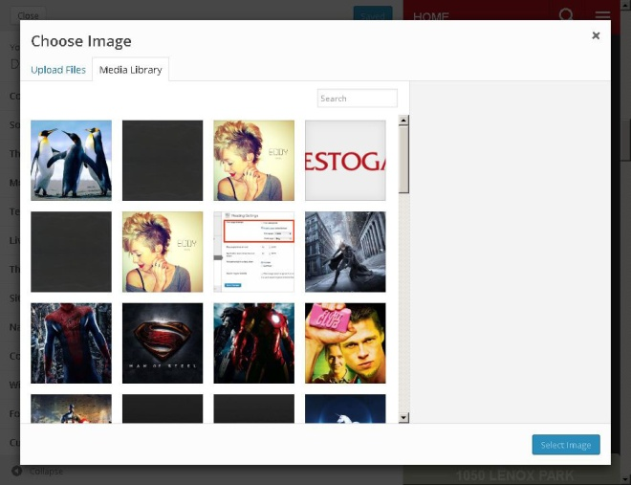

There are three different types of Theme Image selections that can be made.

### Default Thumbnail Image

Most ArsTropica Responsive Framework Child Themes rely on post images as part of the theme's appearance. For posts without images, a default image can be set that will appear wherever the post is displayed as part of a list.

### Company Logo

This setting controls the image that will appear in the contact form and Company Logo and Link widget.

### Site Favicon

This setting allows you to upload a custom favicon image to be used for the blog.

## Import / Export

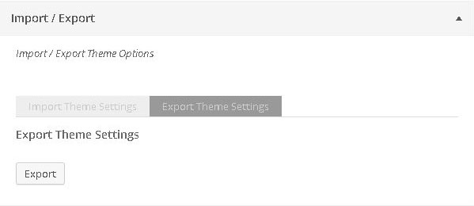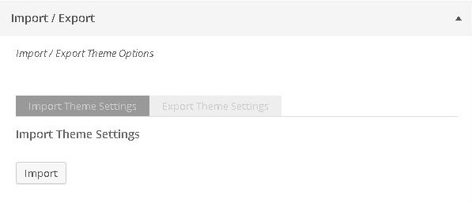

The Import / Export section allows you to save and load Theme Settings options for the blog.

## Reset Theme Options

The Reset Theme Options section allow you to reset all **Appearance based settings**, while keeping the other settings intact.

**Note that this action is irreversible.**

# Individual Theme Settings



Below is a table of recommended values for the theme settings section for each ArsTropica Responsive Framework Child Theme. When active, each theme will initially default to these settings unless manually changed.

## Default Theme Settings Values

|  |  |  |  |  |  |
| --- | --- | --- | --- | --- | --- |
|  | Number of Words in Excerpt | Number of Words in Excerpt on Homepage | Number of Posts per Page | Number of Posts on Homepage | Enable Sticky Navigation |
| Theme 1 | 55 | 55 | 9 | 3 | true |
| Theme 2 | 55 | 25 | 9 | 3 | false |
| Theme 3 | 55 | 55 | 9 | 3 | true |
| Theme 4 | 55 | 55 | 9 | 3 | false |
| Theme 5 | 20 | 20 | 5 | 4 | true |

# Using a Static Home Page

Child Themes with static homepage templates are supported by the ArsTropica Responsive Framework.

In addition to the standard theme files described above, a Custom Page Template can be used to display a **static** homepage (that is, a page that doesn't behave like a default blog).

## Custom Page Templates

To create a custom page template make a new file starting with a Template Name inside a PHP comment. It must start with the string "Template Name:" in a comment. After that you can to add other information, like::

<?php

/*

* Template Name: My Custom Page

* Description: A Page Template with a darker design.

*/

// Code to display Page goes here...

Once you upload the file to your Theme's folder, the template name, "My Custom Page", will list in the Edit Page screen's Template dropdown. (The select list has a maximum width of 250px, so longer names may be cut off.)

A quick, safe method for making a new Page template is to use with a copy of your theme's index.php: This way you start off with the HTML structure of your other pages, then you can edit as needed.

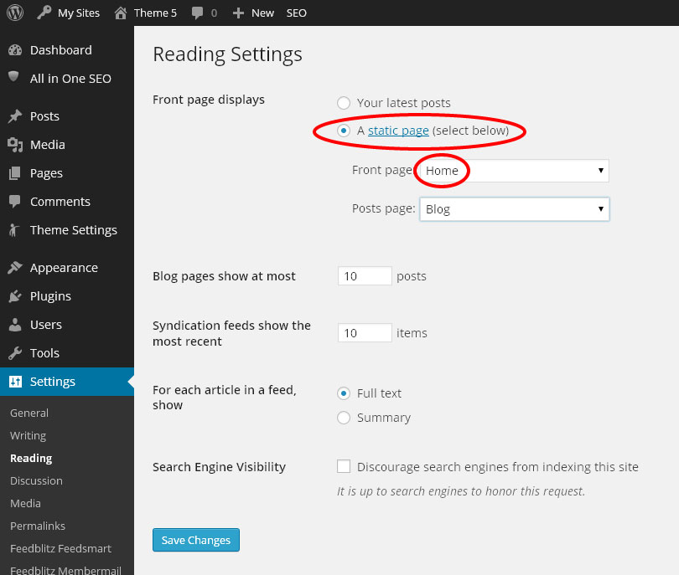

First, create and publish a Page in the WordPress Page editor.

Under Settings > Reading, select the static page option and choose the page you created as the Front page.

# Creating a Menu

The ArsTropica Responsive Framework uses the WordPress custom menu feature. Once you have published some pages and posts, you are ready to create a menu.

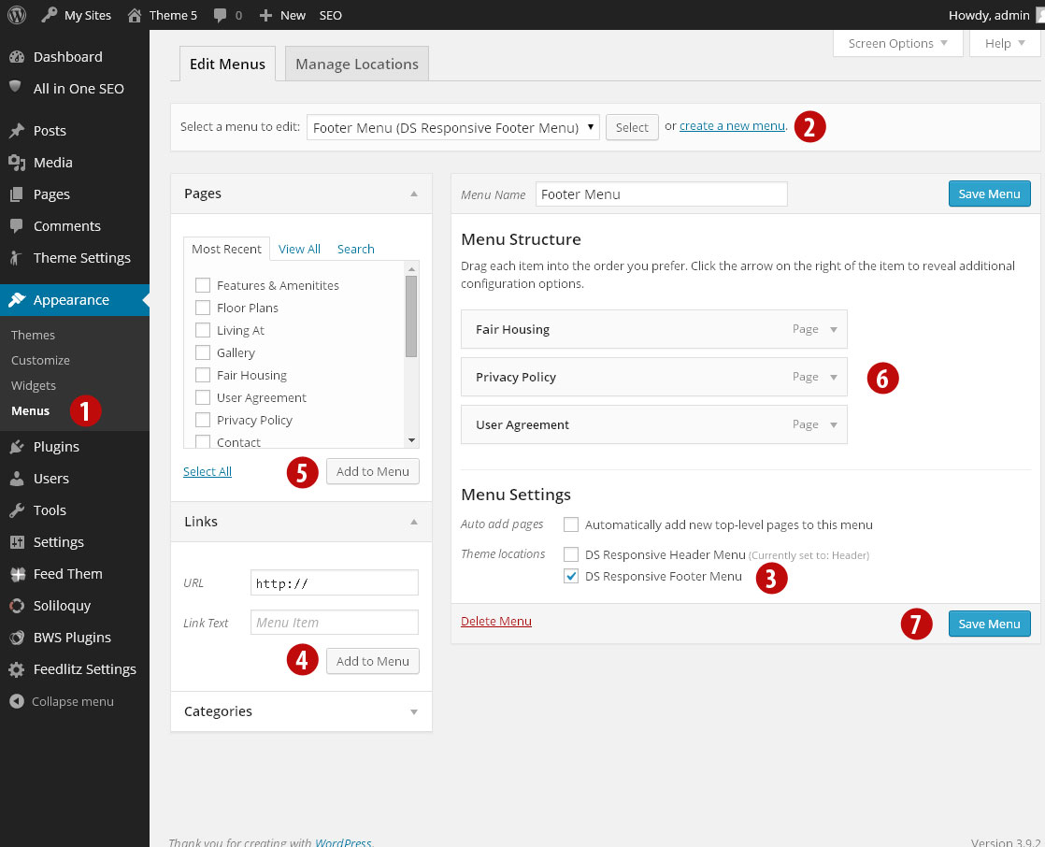

1. Mouse over "Appearance" and select "Menus."
2. Click the "create a new menu" link to create a new Menu. Add a "Menu Name."
3. If this menu will be used as your "Footer Menu," select it in Theme Locations. You may see other available locations depending on your theme. Just create another menu following these same steps and add the new menu to the other locations.
4. To add a "Custom Link" to the menu, add the "URL" and the "Link Text" that will be used for the link. Click the "Add to Menu" button.
5. Add "Pages" to your menu by adding a check mark to the pages you want to add and click the "Add to Menu" button.
6. All of the links you added to the menu will appear in a list. Click and drag the boxes to change the order of the menu items. You also can create a sub navigation menu item by moving a box so it is indented to the right of all the other boxes.
7. Be sure to click the "Save Menu" button to save your menu.

If you do not see all of the menu options available, for example, the box of Posts does not appear, click the "Screen Options" link and add a check mark next to the missing item. When you are done, click the "Screen Options" link again to minimize the feature.

# Plugins

The ArsTropica Responsive Framework uses several custom and third party plugins in association with the Child Theme. These plugins contribute to the features and functionality provided by the framework.

Some, if not all, of the plugins are necessary in order for the Child Theme to function correctly.

## Plugin Inventory

### Required Plugins

The following list of plugins are required by the framework.

* Soliloquy Slider (or Lite version)

http://soliloquywp.com/

https://wordpress.org/plugins/soliloquy-lite/

* Regenerate Thumbnails

http://wordpress.org/plugins/regenerate-thumbnails/

### Optional Plugins

The following list of plugins are not required by the framework, but used to provide additional functionality.

* Yet Another Related Posts Plugin

https://wordpress.org/plugins/yet-another-related-posts-plugin/

* ArsTropica Guest Theme Preview Plugin

https://github.com/arstropica/at_preview_plugin

### Theme Plugins

The following list of plugins are pre-installed by the framework.

* Featured Posts
* Company Logo & Link
* Mobile Contact Form
* Related Posts
* Theme Social Icons

## Plugin Settings

### Soliloquy Slider

http://soliloquywp.com/

Soliloquy is a responsive WordPress slider plugin. It comes with the following add-ons that are used by some of the ArsTropica Responsive Child Themes.

* Carousel Addon
* Lightbox Addon
* Themes Addon
* Thumbnails Addon

#### The Main Slider Page

The main slider table lists out all of the sliders you have created. It lists important information like the slider title, slider shortcode and template tag, and number of images in the slider amongst other things. You can also view the contextual help tab at the top of the page if you need any extra explanation for anything you may see on the screen.

#### Creating Your First Slider

To begin creating your first slider, click Add New at the top of your Soliloquy Home Screen.

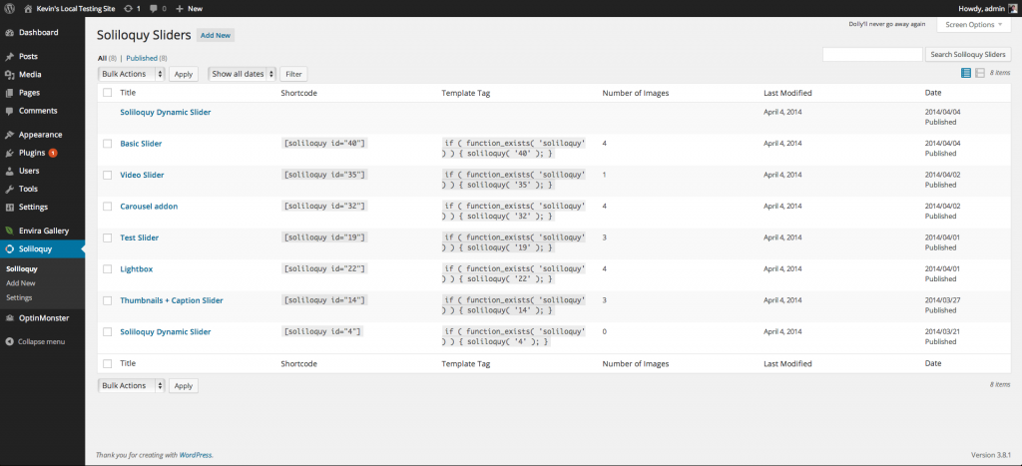

Which brings you to the following screen.

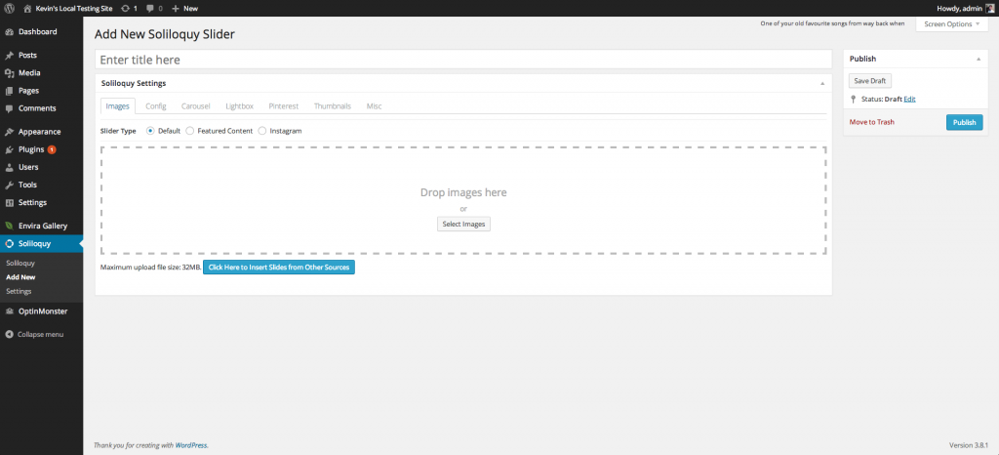

The first thing you want to do is give your slider a title, such as “Creating Your First Slider“. Once you have set your title, let’s start uploading some images! Click on the Click Here to Upload Images button to get started. A lightbox display will open that will allow you to upload images from your computer, from an external URL or even from your media library.

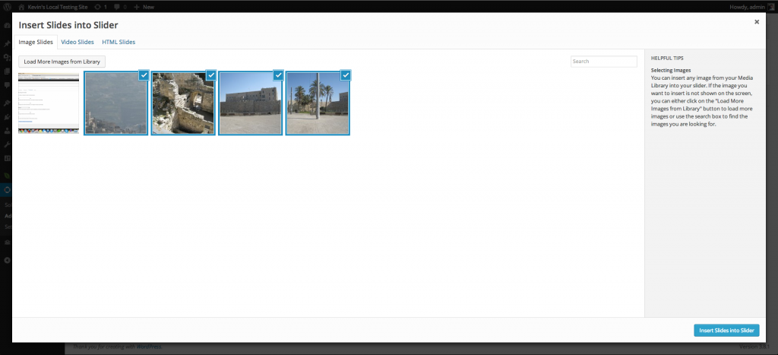

Once your images are uploaded, you can either click on the Insert Slides into Slider button. Now, you screen should look similar to the screenshot below.

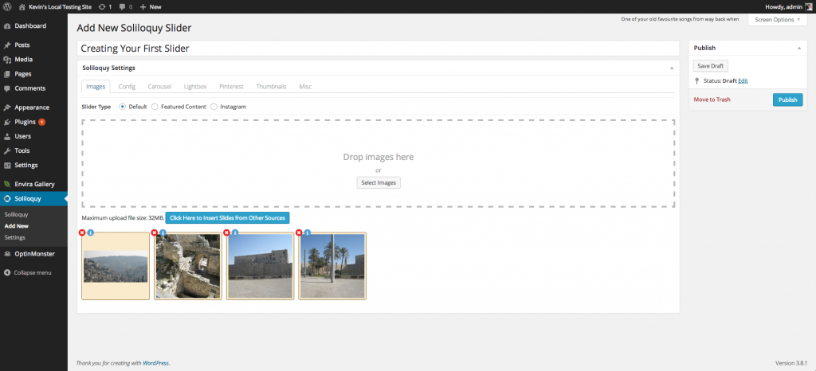

From this screen, hover over the images. You will notice that you can drag and drop them in order. Simply click and drag an image to a different location to sort your slides. The slide order will automatically be updated for you.

If you click on the Pencil icon, a lightbox will open that will allow you to edit each individual slide’s metadata. This includes the image title, alternate text, link URL and caption along with other things. You can also utilize the internal linking feature here by clicking existing link item. Fill out the metadata information as indicated below.

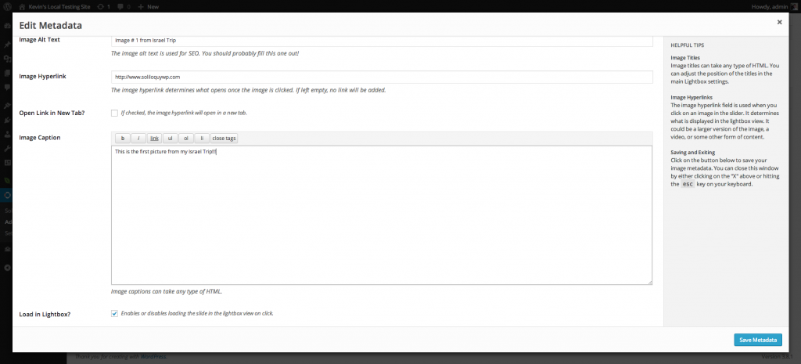

Image captions can accept any type of HTML, including (but not limited to) iframe, h1 and form tags. This gives you the ultimate ability to transform your sliders into anything imaginable.

#### Adjusting Slider Settings

Once you have modified your image settings, it’s time to adjust your slider settings. The next menu you will be brought to is the **Config** menu, like the screenshot below.

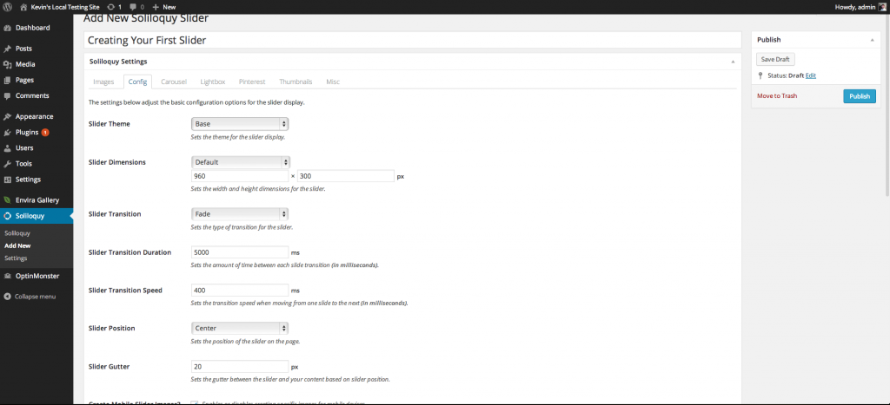

ArsTropica Responsive Child Themes use two basic types of slider: Header Sliders -- which appear at the top of the blog, and Post / Gallery Sliders -- which appear inside content like posts or pages. Each type of slider has different configuration requirements in order to display correctly in the theme.

##### Header Sliders

Header Sliders are typically full- width sliders that display above or below the navigation menu at the top of the page. The following screenshot highlights required settings for the header slider in most child themes.

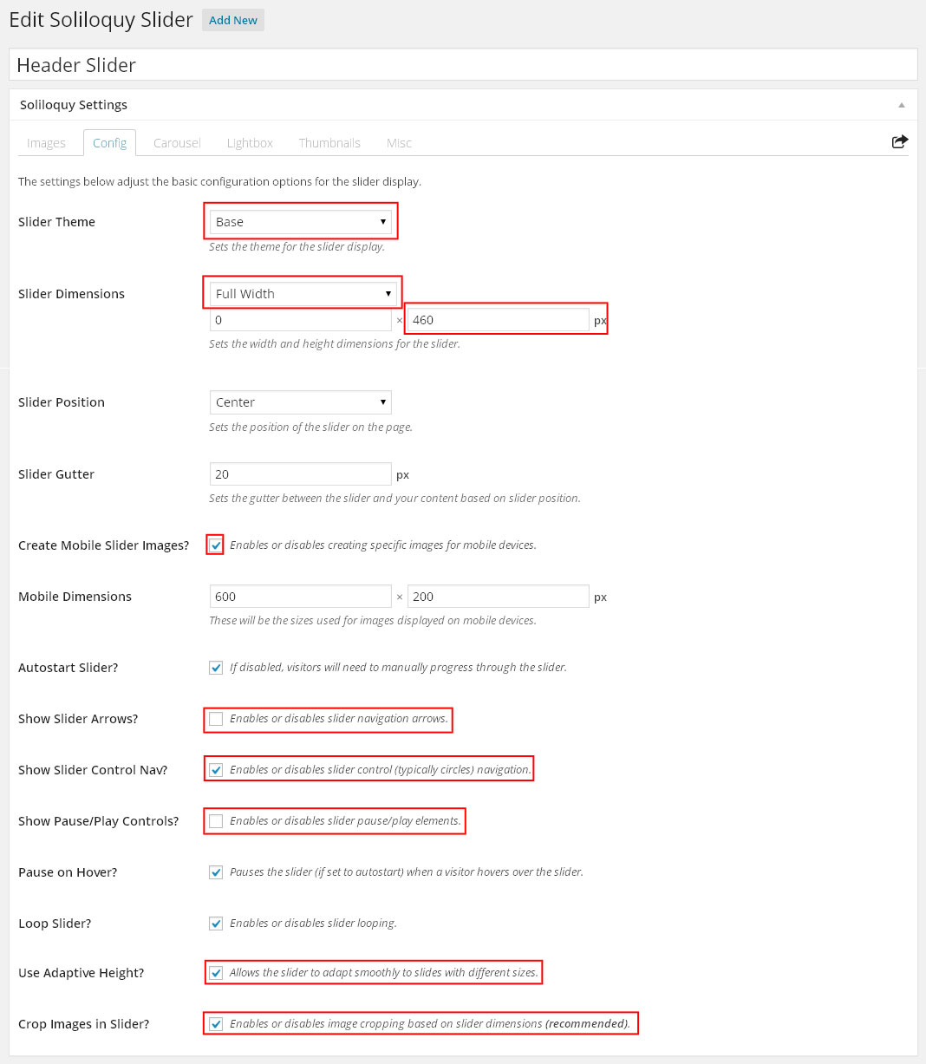

##### Carousel Sliders

Some Child Themes use a carousel effect in their header slider. In order to enable this effect, the Carousel Addon needs to be enabled and configured. The below screenshot highlights additional required settings for the Carousel Slider.

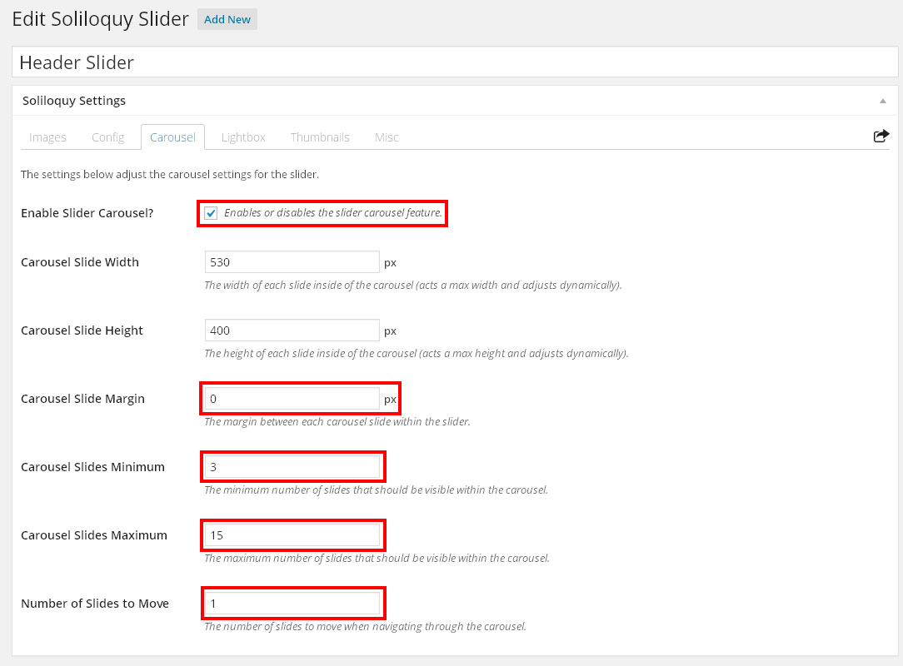

##### Post / Gallery Slider

Post / Gallery sliders appear inside blog content and are activated by shortcode entered in the WordPress Post / Page editor.

The Post / Gallery slider uses Soliloquy's addons to provide navigation and preview functionality.

The following screenshot highlights required settings for the Post / Gallery slider config page.

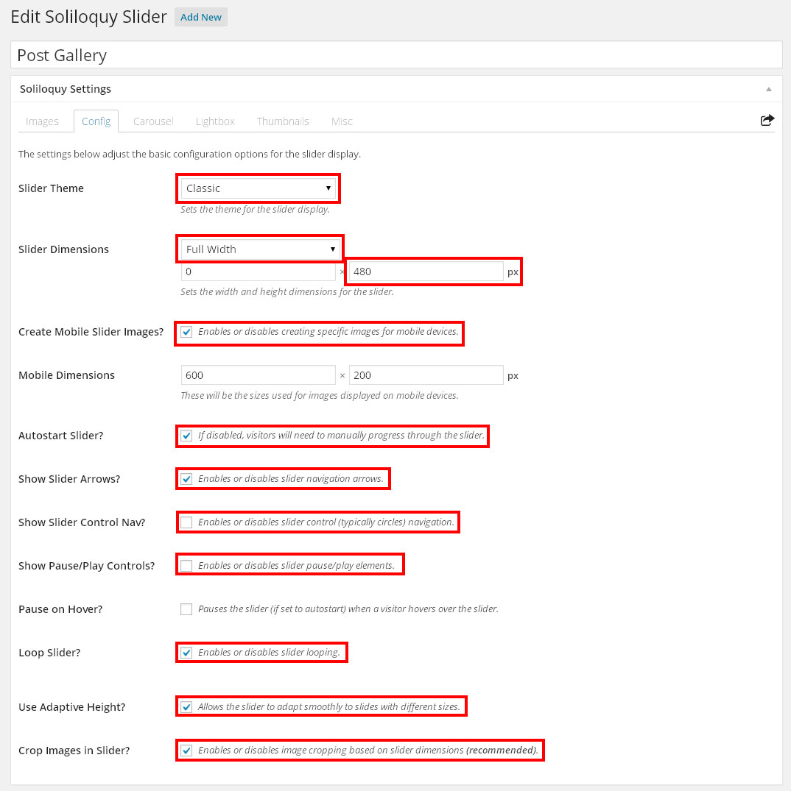

The Post / Gallery Slider also uses the Themes, Lightbox and Thumbnails addons. The following screenshots highlight **recommended** settings for each of the addons.

###### Lightbox Addon

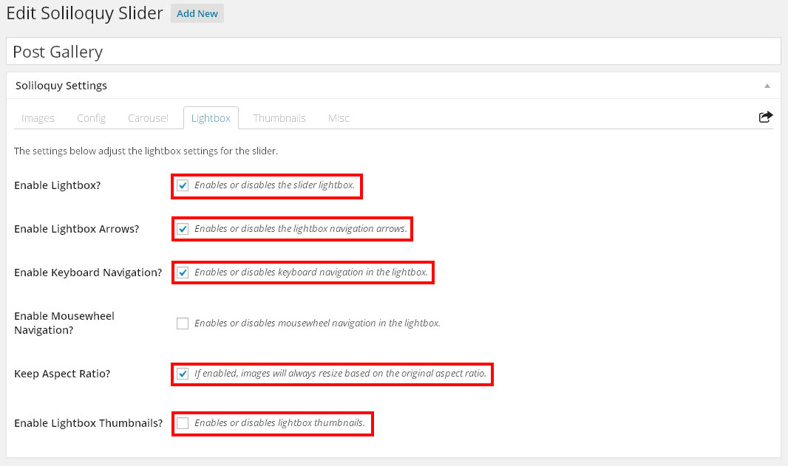

###### Thumbnails Addon

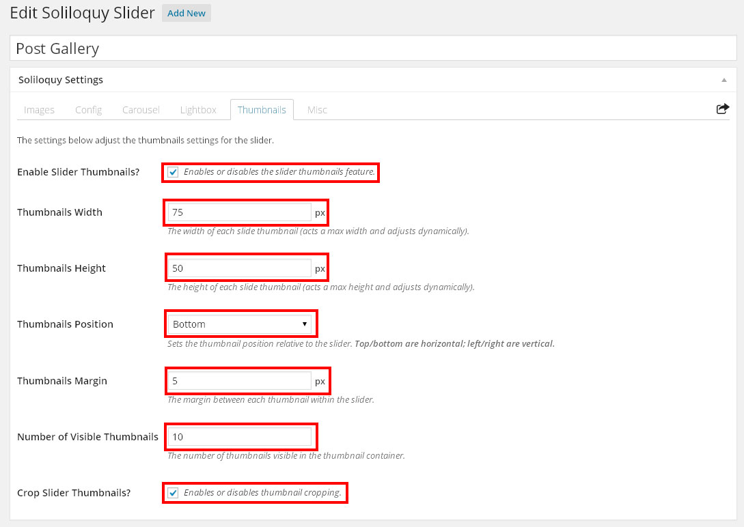

#### Publishing And Using The Slider

Click on the Publish button to make your slider active, and, if applicable, visit a post or page edit screen.

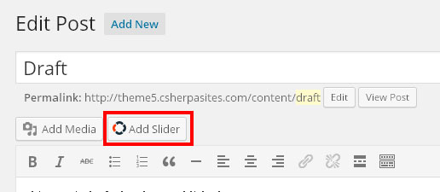 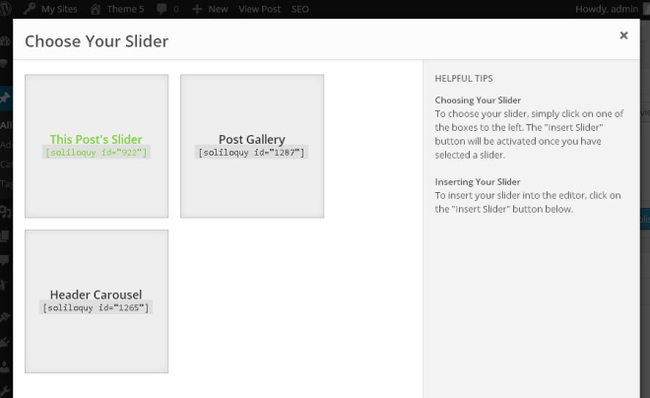

At the top of the editor, you will find a button that says "Add Slider". Click on that button to bring up a lightbox where you can select to insert a slider into your post or page. Once you have chosen the one you created, click on the button to insert the slider. Save your post or page and check out your updated site!

### Regenerate Thumbnails

If content is imported into WordPress from another blog, it is sometimes necessary to resize any images associated with the content so the ArsTropica Responsive Framework can display them correctly.

The Regenerate Thumbnails plugin allows you to resize all media in your blog to adapt to the active theme's requirements.

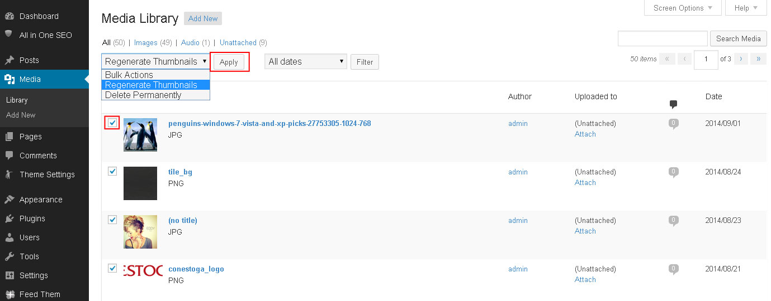

Regenerate Thumbnails can be run from the Media Library by selecting all available images and choosing "Regenerate Thumbnails" from the drop-down menu at the top and clicking the "Apply"  
 button. The plugin will then run through all the valid images in the blog and resize them according to the active theme requirements.

### Yet Another Related Posts Plugin

https://wordpress.org/plugins/yet-another-related-posts-plugin/

Yet Another Related Posts is a third party plugin that analyzes post content and metadata to display additional related content.

The ArsTropica Responsive Framework uses this plugin to integrate related posts below single post content.

After enabling the plugin, an additional configuration step is required in order for the framework to control **where and if** related posts are displayed.

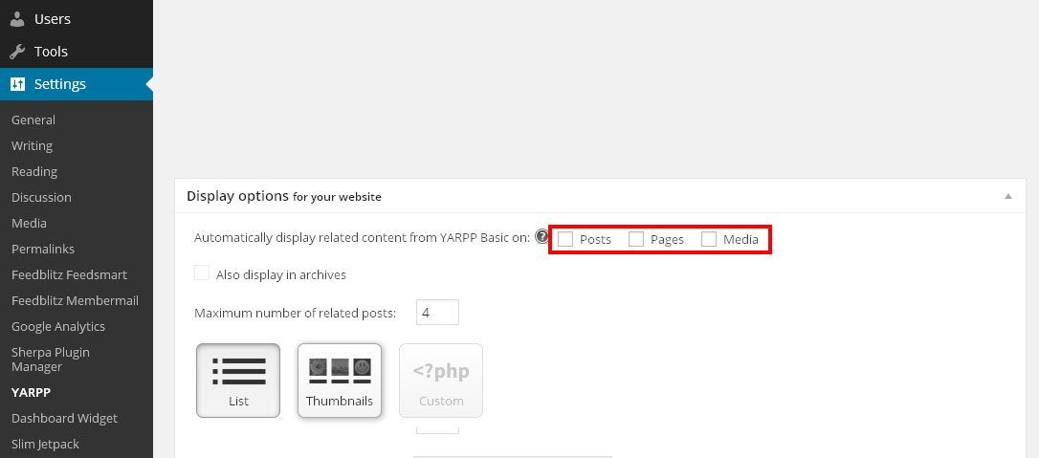

Navigate to Settings > YARPP in the admin menu and make sure that all the boxes for automatic display are unchecked so that the framework and not the plugin can control display of related posts.

To enable related posts in a theme, check the "Display Related Posts" box in Theme Settings.

### ArsTropica Guest Theme Preview Plugin

https://github.com/arstropica/at_preview_plugin

The ArsTropica Guest Theme Preview plugin allows blog visitors to access the Theme Settings in a preview screen without having to log in to the blog.

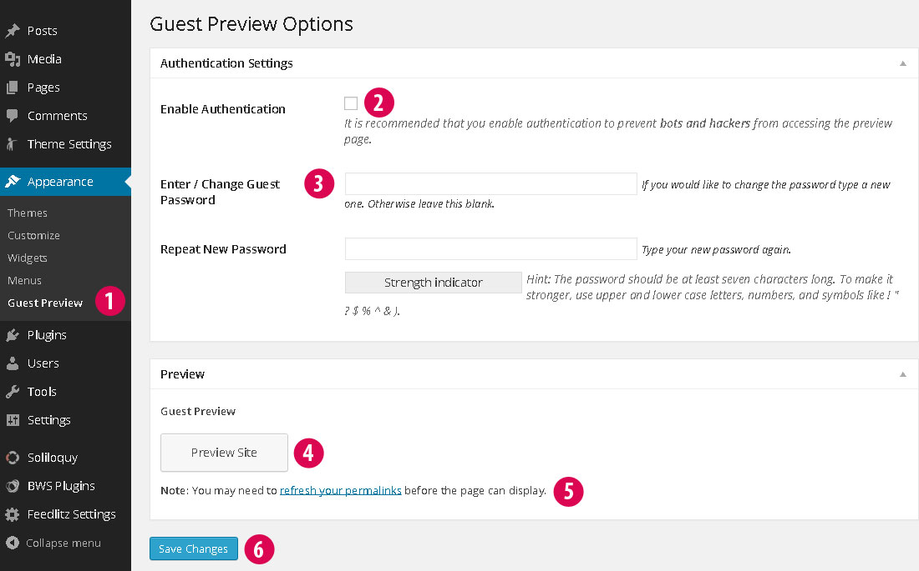

1. After activating the plugin, check the "Enable Front End Theme Customizer for Guests" box in Theme Settings and save. Go to the Guest Preview Settings page under Appearance in the admin menu.
2. If you want to password protect the page, check the "Enable Authentication" box.
3. Enter and confirm a password.
4. Preview the guest page in a new window . You will need to save changes if you have activated Authentication. (Note that this will log you out of your current account.)
5. If the page doesn't display, try refreshing the site's permalinks.
6. Save the changes.

Navigate to Settings > Permalinks in the admin menu. Click "Save Changes" to refresh the URL rewriting settings in WordPress.

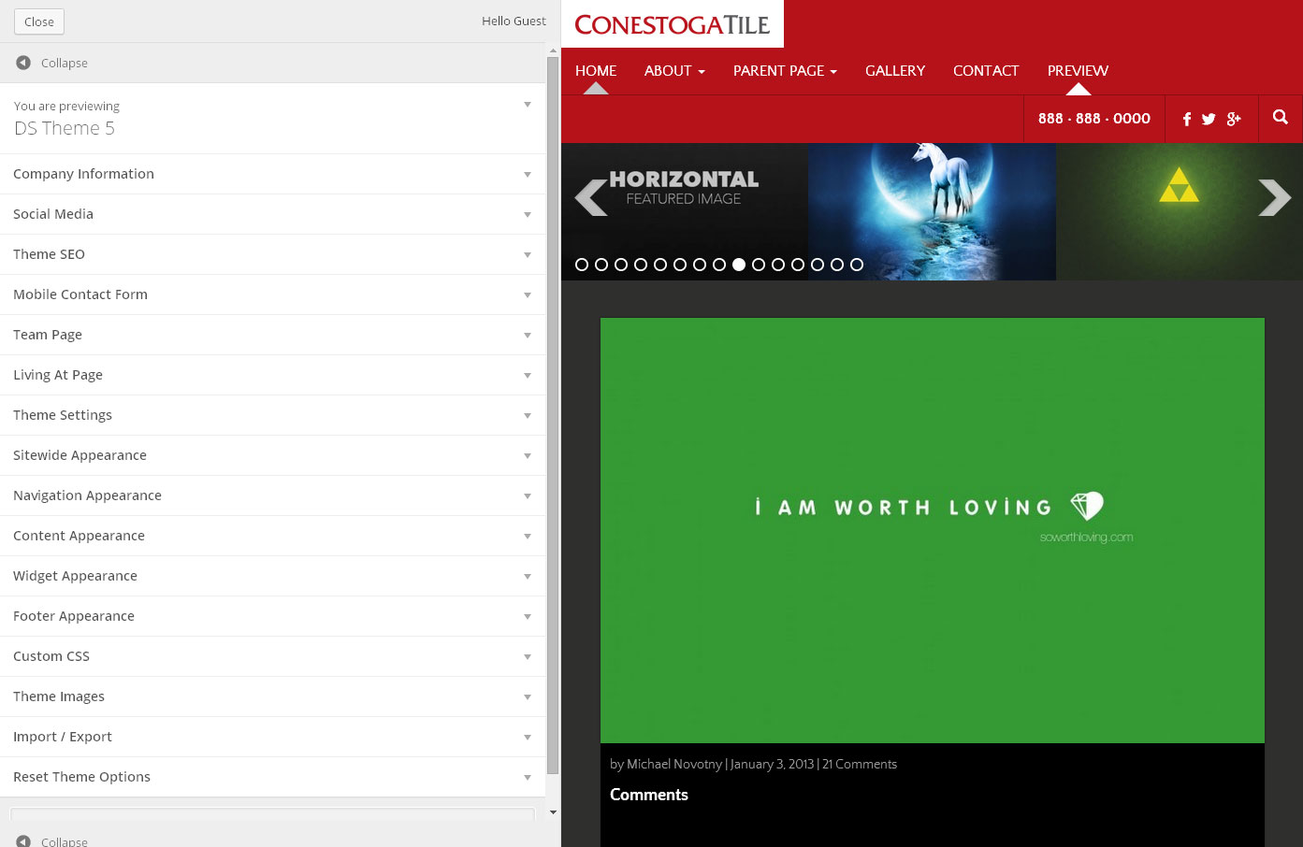

The Guest Preview page can be accessed at the "/guestpreview" URL for your blog.

A link to the Guest Preview page can be generated in a post or page by entering the following shortcode:

[guestpreview]Link Text[/guestpreview]

Note that once the page has been accessed, the visitor will be logged into the blog as the Guest user and will not be able to return to any other blog page until they have logged out.

### ArsTropica Featured Posts

The ArsTropica Featured Posts plugin activates the "ArsTropica Featured Posts" widget which displays featured posts in a widget area.

### Company Logo & Link

The Company Logo & Link plugin activates the "Company Logo & Link" widget which displays the logo and website / blog link specified under Theme Settings.

### Mobile Contact Form

The Mobile Contact Form plugin activates the "Mobile Contact Form" widget which displays a responsive modal contact form or an email link to the blog admin email address.

### Related Posts

The Related Posts plugin activates the ArsTropica Responsive Framework integrated related posts feature on single posts. It requires the "Yet Another Related Posts" plugin to function correctly.

### Theme Social Icons

The Theme Social Icons plugin activates the "Theme Social Icons" widget which displays linked icons to those social media services that have been configured under Theme Settings.

# Widgets

The ArsTropica Responsive Framework uses various "widget areas" to position and display WordPress widgets in child themes.

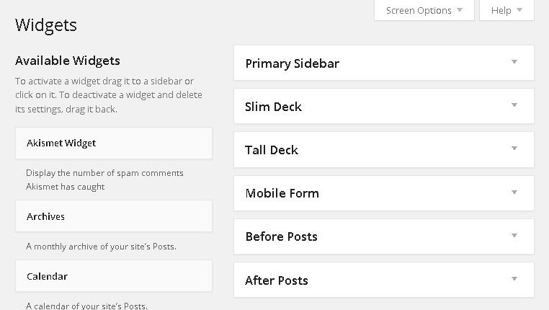

This is an example of the widget areas available in a child theme. Each child theme contains its own set of widget areas configured to work with the theme's layout and design.

WordPress widgets may be dragged into a specific widget area to display them at a predetermined location in the theme.

Placeholders for a theme's widget areas may be displayed by checking the "Show Widget Placeholders" box under Theme Settings.

## ArsTropica Featured Posts

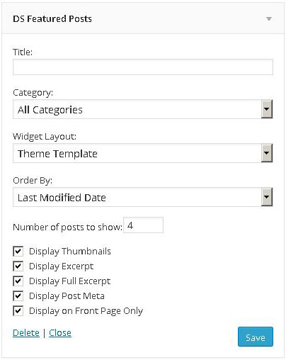

The " ArsTropica Featured Posts" widget displays a list of featured posts. It has several configuration parameters that affect the displayed posts.

##### Category

Limits the featured posts to a specific category

##### Widget Layout

Vertical - displays the featured posts in a vertical orientation

Horizontal - displays the featured posts in a horizontal orientation

Grid - displays the featured posts in a 2 x 2 grid orientation.

Theme Template - displays the featured posts as the regular theme posts

##### Order By

Changes the order of display by one of random, last modified or post title.

##### Display Thumbnails

Displays thumbnail images with the featured posts

##### Display Excerpt

Displays shortened post excerpts with the featured posts

##### Display Full Excerpt

Displays full length post excerpts with the featured posts

##### Display Post Meta

Displays author, date, category, tags and comment information with the featured posts

##### Display on Front Page Only

Displays the widget only on the blogs homepage

## Company Logo & Link

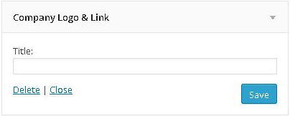

The "Company Logo & Link" widget displays the logo image specified under "Theme Images" on the Theme Settings page. The logo is linked to either the website specified under "Social Media" on the Theme Settings page, or the blog URL if no website is specified.

## Mobile Contact Form

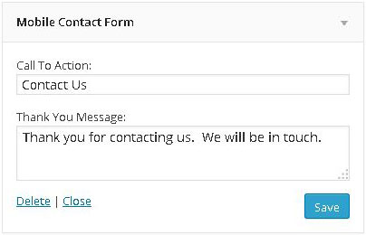

The " Mobile Contact Form" widget displays a button and modal contact form or email link when the site is viewed on a mobile device. If a customer "Sherpa ID" has been entered under Theme Settings, the widget will display a contact form that notifies the client's Dashboard account when the form is submitted. If a customer "Sherpa ID" has not been entered, the widget will display a link to the blog admin account email instead.

 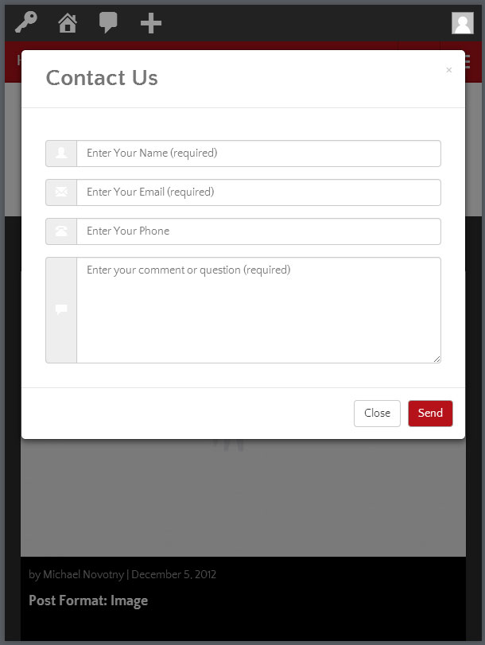

The widget must be placed in the "Mobile Form" widget area in order to activate on mobile devices.

## Theme Social Icons

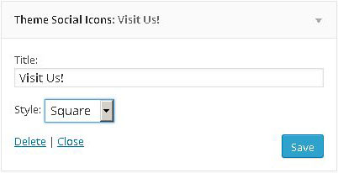

The "Theme Social Icons" widget displays linked icons to the Social Media profiles entered under Social Media in the Theme Settings page.

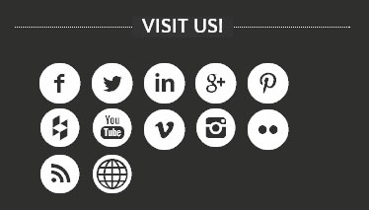

The widget can be configured with different style options that change the appearance of the icons.

##### Style

Choose between circular, open or square icons.

## Facebook Like Box

To make Facebook Like Box automatically adapt its width to the different screen resolutions, we need to modify the code generated from Facebook as shown in the snapshots illustrated for the steps below:

1. Remove the first width value in the code.

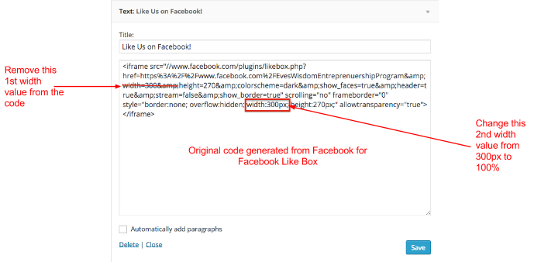

1. Change the value of the 2nd width in the code to 100%

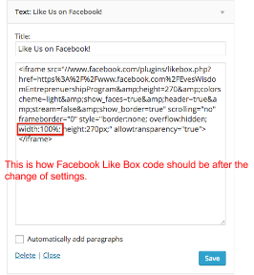

# Shortcodes

The ArsTropica Responsive Framework provides certain shortcodes (i.e., WordPress shortcuts). A shortcode is a WordPress-specific code that lets you perform complex actions with very little effort.

## Available Shortcodes

*[guestpreview]* inserts a link to the Guest Preview page (requires Guest Preview plugin installation and activation under Theme Settings).

*[blogurl]* displays the URL of the blog

*[blogname]* displays the name of the blog

*[blogdesc]* displays the description of the blog

# Filters Reference

## Framework Filters

These filters apply to every child theme of the ArsTropica Responsive Framework.

### at_google_authorship_rel

**Default Value:** __("author", "at-responsive-theme"))

Applied to the 'rel' attribute of the link to an author's Google + profile page.

### at_responsive_comments_popup_link

**Default Value:** at_responsive_comments_popup_link()

Applied to the output of the comments popup link in at_responsive_comments_popup_link.

### at_responsive_content_grid

**Default Value:** at_responsive_set_content_grid_values ()

Applied to the output of at_responsive_set_content_grid_values controlling the bootstrap column values for different sections of the site.

### at_responsive_content_grid_classes

**Default Value:** $default = array('full' => '', 'row' => '', 'home' => '', 'archive' => '', 'single' => '', 'sidebar' => '', 'secondary' => '', 'loop_start' => '', 'loop_end' => '', 'pagination' => '', 'comments' => '', 'featured' => '')

Applied to the array of css class names for different sections of the site.

### at_responsive_dropdown_menu_classes

**Default Value:** array('dropdown-menu')

Applied to the classes assigned to the navigation submenu list

### at_responsive_excerpt

**Default Value:** at_responsive_post_excerpt()

Applied to the output of the excerpt text generated by at_responsive_post_excerpt

### at_responsive_nav_menu_args

**Default Value:** at_responsive_menu_walker::start_el(&$output, $item[,…], $args = array()[,…])

Applied to the $args object used for navigation menu items.

### at_responsive_pagination_links

**Default Value:** at_responsive_pagination()

Applied to the output of the pagination code in at_responsive_pagination.

### at_responsive_post_entry

**Default Value:** at_responsive_get_post_entry()

Applied to post entry output in at_responsive_get_post_entry.

### at_responsive_theme_mod_{$setting_id}

**Default Value:** $default

Applied to the default value for Custom Control values

## Child Theme Filters

These filters apply to existing child themes of the ArsTropica Responsive Framework, and may be added to future themes during development.

### at_responsive_child_menu_end_lvl

**Default Value:** "$indent</ul>\n", $indent

Applied to the output of the ending tag for the navigation submenu list

### at_responsive_child_menu_start_lvl

**Default Value:** "\n{$indent}<ul role=\"menu\" class=\"" . implode(' ', $c) . "\">\n", $indent

Applied to the output of the opening tag for the navigation submenu list

### at_responsive_child_theme_mod_{$setting_id}

**Default Value:** $default

Applied to the default value for Custom Control values

# Hooks Reference

## Framework Hooks

These hooks occur in every child theme of the ArsTropica Responsive Framework.

### at_responsive_after_entry

This hook executes after the content in main loop

### at_responsive_hero

This hook executes at the beginning of the header

### at_responsive_loop_end

This hook executes after the main loop

### at_responsive_loop_start

This hook executes before the main loop

### at_responsive_mobile_contact

This hook executes inside the header in a container visible only on mobile resolutions.

## Child Theme Hooks

These hooks occur in existing child themes of the ArsTropica Responsive Framework, and may be added to future themes during development.

### at_responsive_primary_sidebar

This hook outputs the content of the primary sidebar (where applicable), including the widget area output.

### at_responsive_secondary_sidebar

This hook outputs the content of the secondary sidebar (where applicable), including the widget area output.

### at_responsive_slim_deck

This hook outputs the content of the slim deck sidebar (where applicable), including the widget area output.

### at_responsive_tall_deck

This hook outputs the content of the tall deck sidebar (where applicable), including the widget area output.

# Error Messages

## Common Error Messages

{placeholder}